**EPIC:**

**ONLINE REHABILITATION TRACKER**

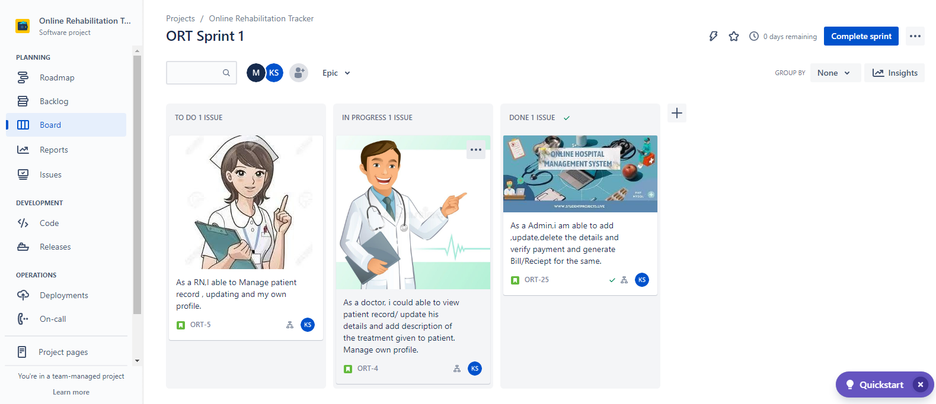

**USER STORY:**

As a Admin ,i am able to add ,update,delete the details and verify payment and generate Bill/Reciept for the same.

**SUBTASK:**

* Admin must first log in with his/her credentials.
* Manage department of hospitals, user, doctor, nurse, pharmacist, laboratorist accounts.
* Admin can update details and also Verify the payment submited by the Patient.

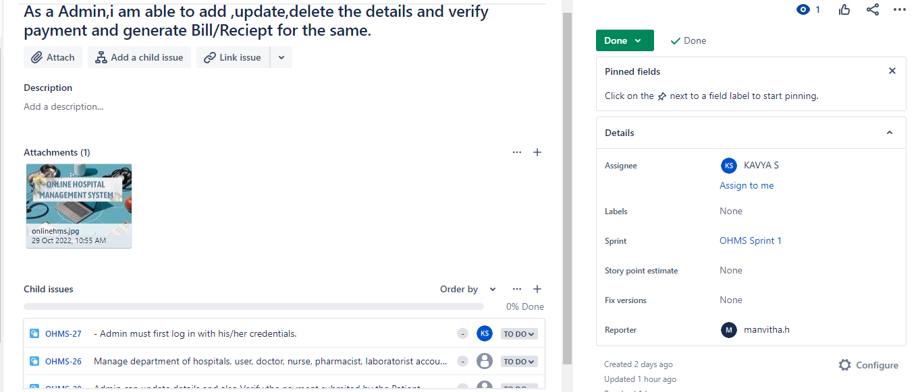

**USER STORY:**

As a doctor, i could able to view patient record/ update his details and add description of the treatment given to patient. Manage own profile.

**SUBTASK:**

* Create, manage appointment with patient .
* Give treatment and provide prescription for patient.
* Issue for operation of patients and creates operation report.

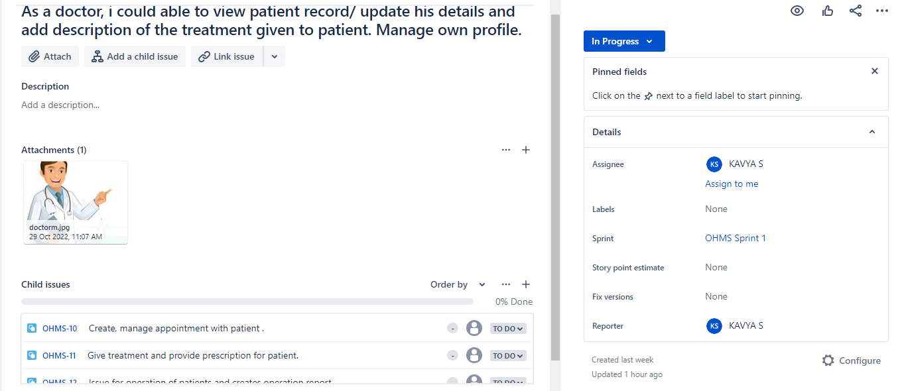

**USER STORY:**

As a RN, I able to Manage patient record , updating and my own profile.

**SUBTASK:**

* Allot bed, ward, cabin for patients.
* Provide medication according to patient prescription.
* Manage blood bank and update status . Keep record of patient operation, baby born and death of patient.

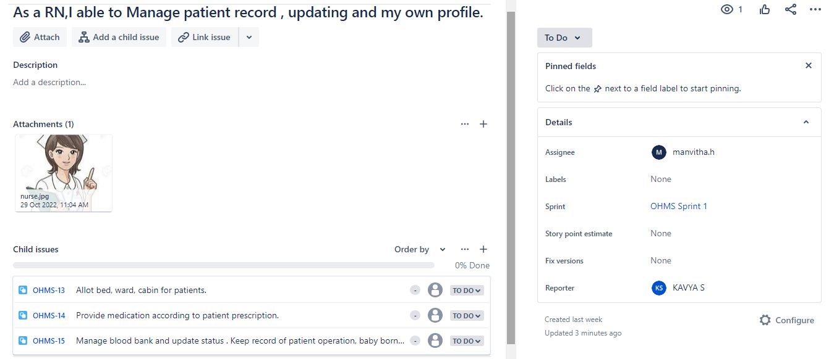

**USER STORY:**

I am a patient. I want to get treatment with regular updates and monitor my health progress. I want to receive this notification from my doctor in advance, so I can schedule my visit conveniently. Manage own profile.

**SUBTASK:**

* View appointment list and status of doctors.
* View doctor list and prescription details.
* Make appointment and Cancel appointment.
* Payment and View Payment History.

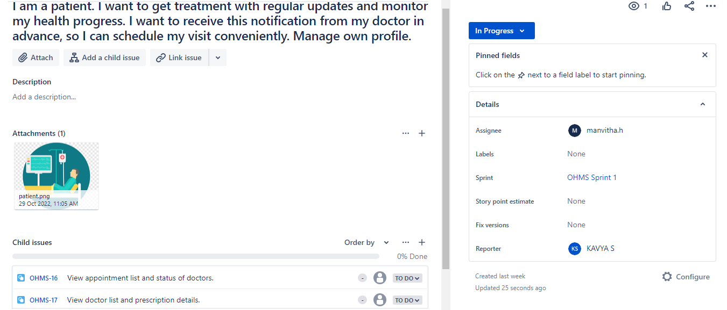

**USER STORY:**

I am an ambulance services Manager for the hospital’s emergency department. I want to receive and respond to messages, to help patients in health emergencies. Manage own profile.

**SUBTASK:**

* I want to best utilize the ambulances and this is only possible when I receive ambulance requests instantly.
* I should be able to open multiple pages that load quickly, notify patients on the availability of ambulances.
* Obtain the user’s address accurately, and confirm sending the ambulance at the location.

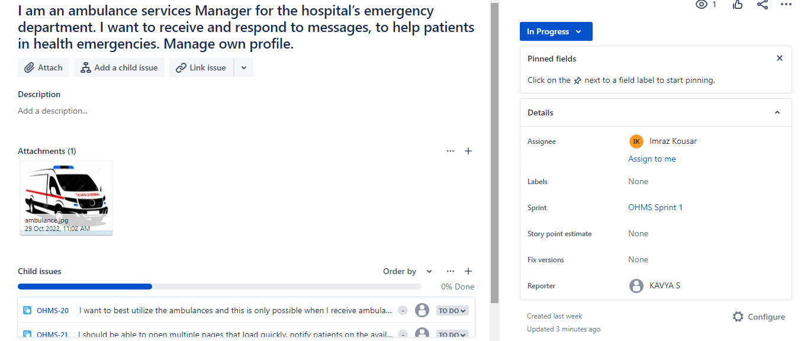

**TASK:**

* Everyone should login with unique user id and password.
* Everyone should login with unique user id and password.

**BUG:**

* It's becomes a difficult task as information is difficult to collect from various register.
* The information generated by various transactions takes time and efforts to be stored at right place.

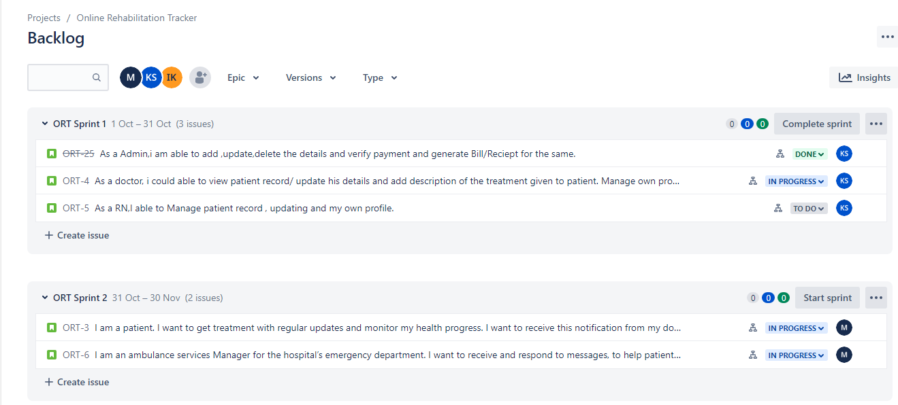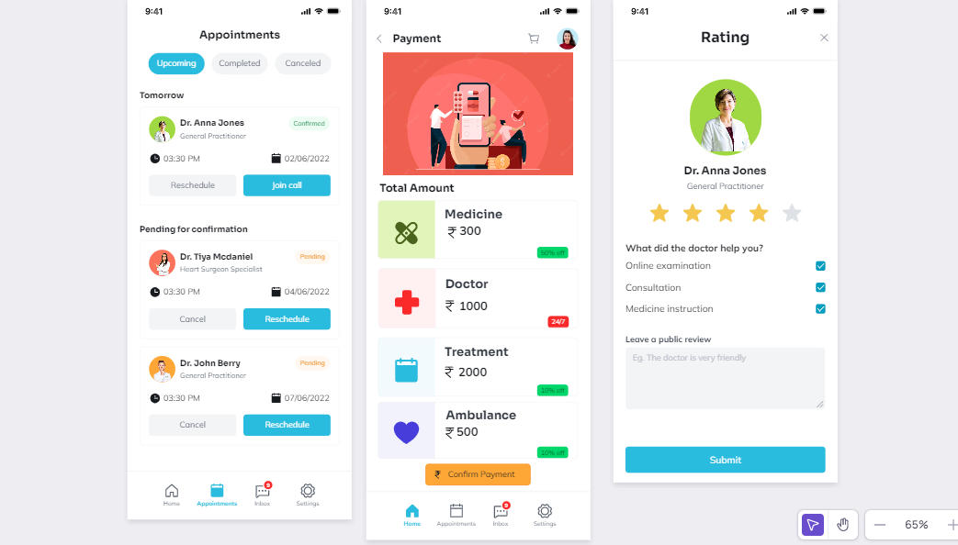

**WIREFRAME:**

